Vocabulary Graphic Organizers – The Frayer Model
Students can use a graphic organizer to develop their understanding of new vocabulary terms. Students can then refer to the vocabulary organizers as needed while they are writing. One of the most well-known graphic organizers for learning vocabulary is the Frayer Model.
How to Use the Frayer Model:
- Give each student a copy of the Frayer Model template or have them divide a paper into four squares. As you are discussing new vocabulary related to the writing topic, have students write the new word in the Oval labeled “word” or in the center of the page if they drew their own model.
- Next, students will write the definition, list some characteristics of the word, and then write examples and non-examples of those words.
- The Frayer Model is completely flexible and adaptable to the needs of your students. You can change the four categories to other items such as Using the Word in a Sentence, Alternative Meanings, Synonyms, Antonyms, Definition in my Primary Language, or Sketch.
- See the next few pages for a blank template you can adapt and some content-specific examples.

Picture
Picture
Word

Word
Word
Word
Non-Examples
Non-Examples
Antonyms

Examples

Definition

Definition

Definition
Definition
Sentence

Picture
Picture

Sentence
Sentence

Definition
A classification of animals that are warm-blooded vertebrates.
Characteristics
Flat shape (not 3D)
4 sides and 4 corners
All corners are square
Characteristics
Have a backbone, give birth to live young, have hair/fur, feed milk to young

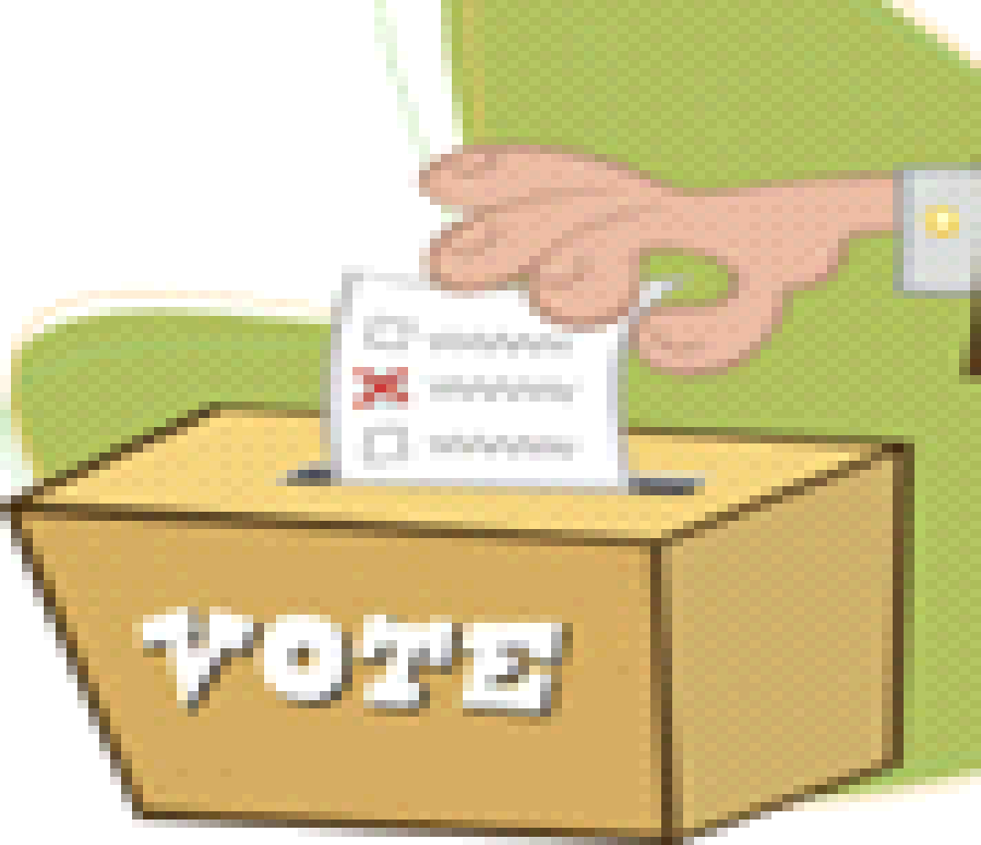
Word

Word
Word
Word
Non-Examples
Non-Examples
Antonyms
Quadrilateral

Mammals

Examples

Weary

Feeling overly tired due to a lack of sleep or too much work

The custodian felt weary after cleaning 10 classrooms and not sleeping well.

Democracy

A system of government run by the people and their elected representatives

Definition
A flat shape with four sides and four corners
Definition
Definition
Examples
Human, cow, horse, whale, cat, dog, elephant, rat

Synonyms
Word Roots
In a Sentence
Characteristics

Spider, frog, snake, fish, lizard, frog, eagle, duck
Tired, worn out, drained, exhausted
Energetic, wide awake, eager, fresh
Energetic, wide awake, eager, fresh
Greek meaning – rule by the people
demos – the people
-cracy – rule by
Image

